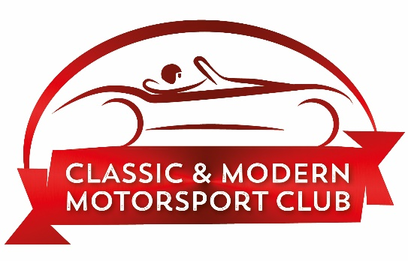
Adult At Risk Safeguarding Statement
Classic and Modern Motorsport Club believes everyone has the right to live free from abuse or neglect regardless of age, ability or disability, sex, race, religion, ethnic origin, sexual orientation, marital or gender status.
Classic and Modern Motorsport Club is committed to creating and maintaining a safe and positive environment and an open, listening culture where people feel able to share concerns without fear of retribution.
Classic and Modern Motorsport Club acknowledges that safeguarding is everybody’s responsibility and is committed to prevent abuse and neglect through safeguarding the welfare of all adults involved.
Classic and Modern Motorsport Club recognises that health, well-being, ability, disability and need for care and support can affect a person’s resilience. We recognise that some people experience barriers, for example, to communication in raising concerns or seeking help. We recognise that these factors can vary at different points in people’s lives.
Classic and Modern Motorsport Club recognises that there is a legal framework within which sports need to work to safeguard adults who have needs for care and support and for protecting those who are unable to take action to protect themselves and will act in accordance with the relevant safeguarding adult legislation and with local statutory safeguarding procedures.
Actions taken by Classic and Modern Motorsport Club will be consistent with the principles of adult safeguarding ensuring that any action taken is prompt, proportionate and that it includes and respects the voice of the adult concerned.

Contact details of our Club Safeguarding Officer (CSO)

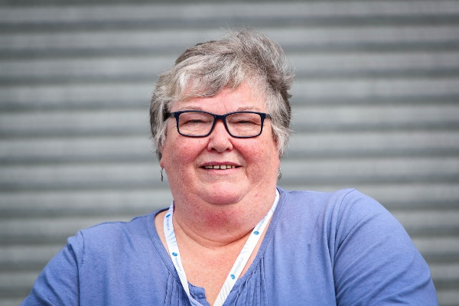
Elaine Brice
01455 848419 or 07740 871 318
elaine.brice@virginmedia.com

