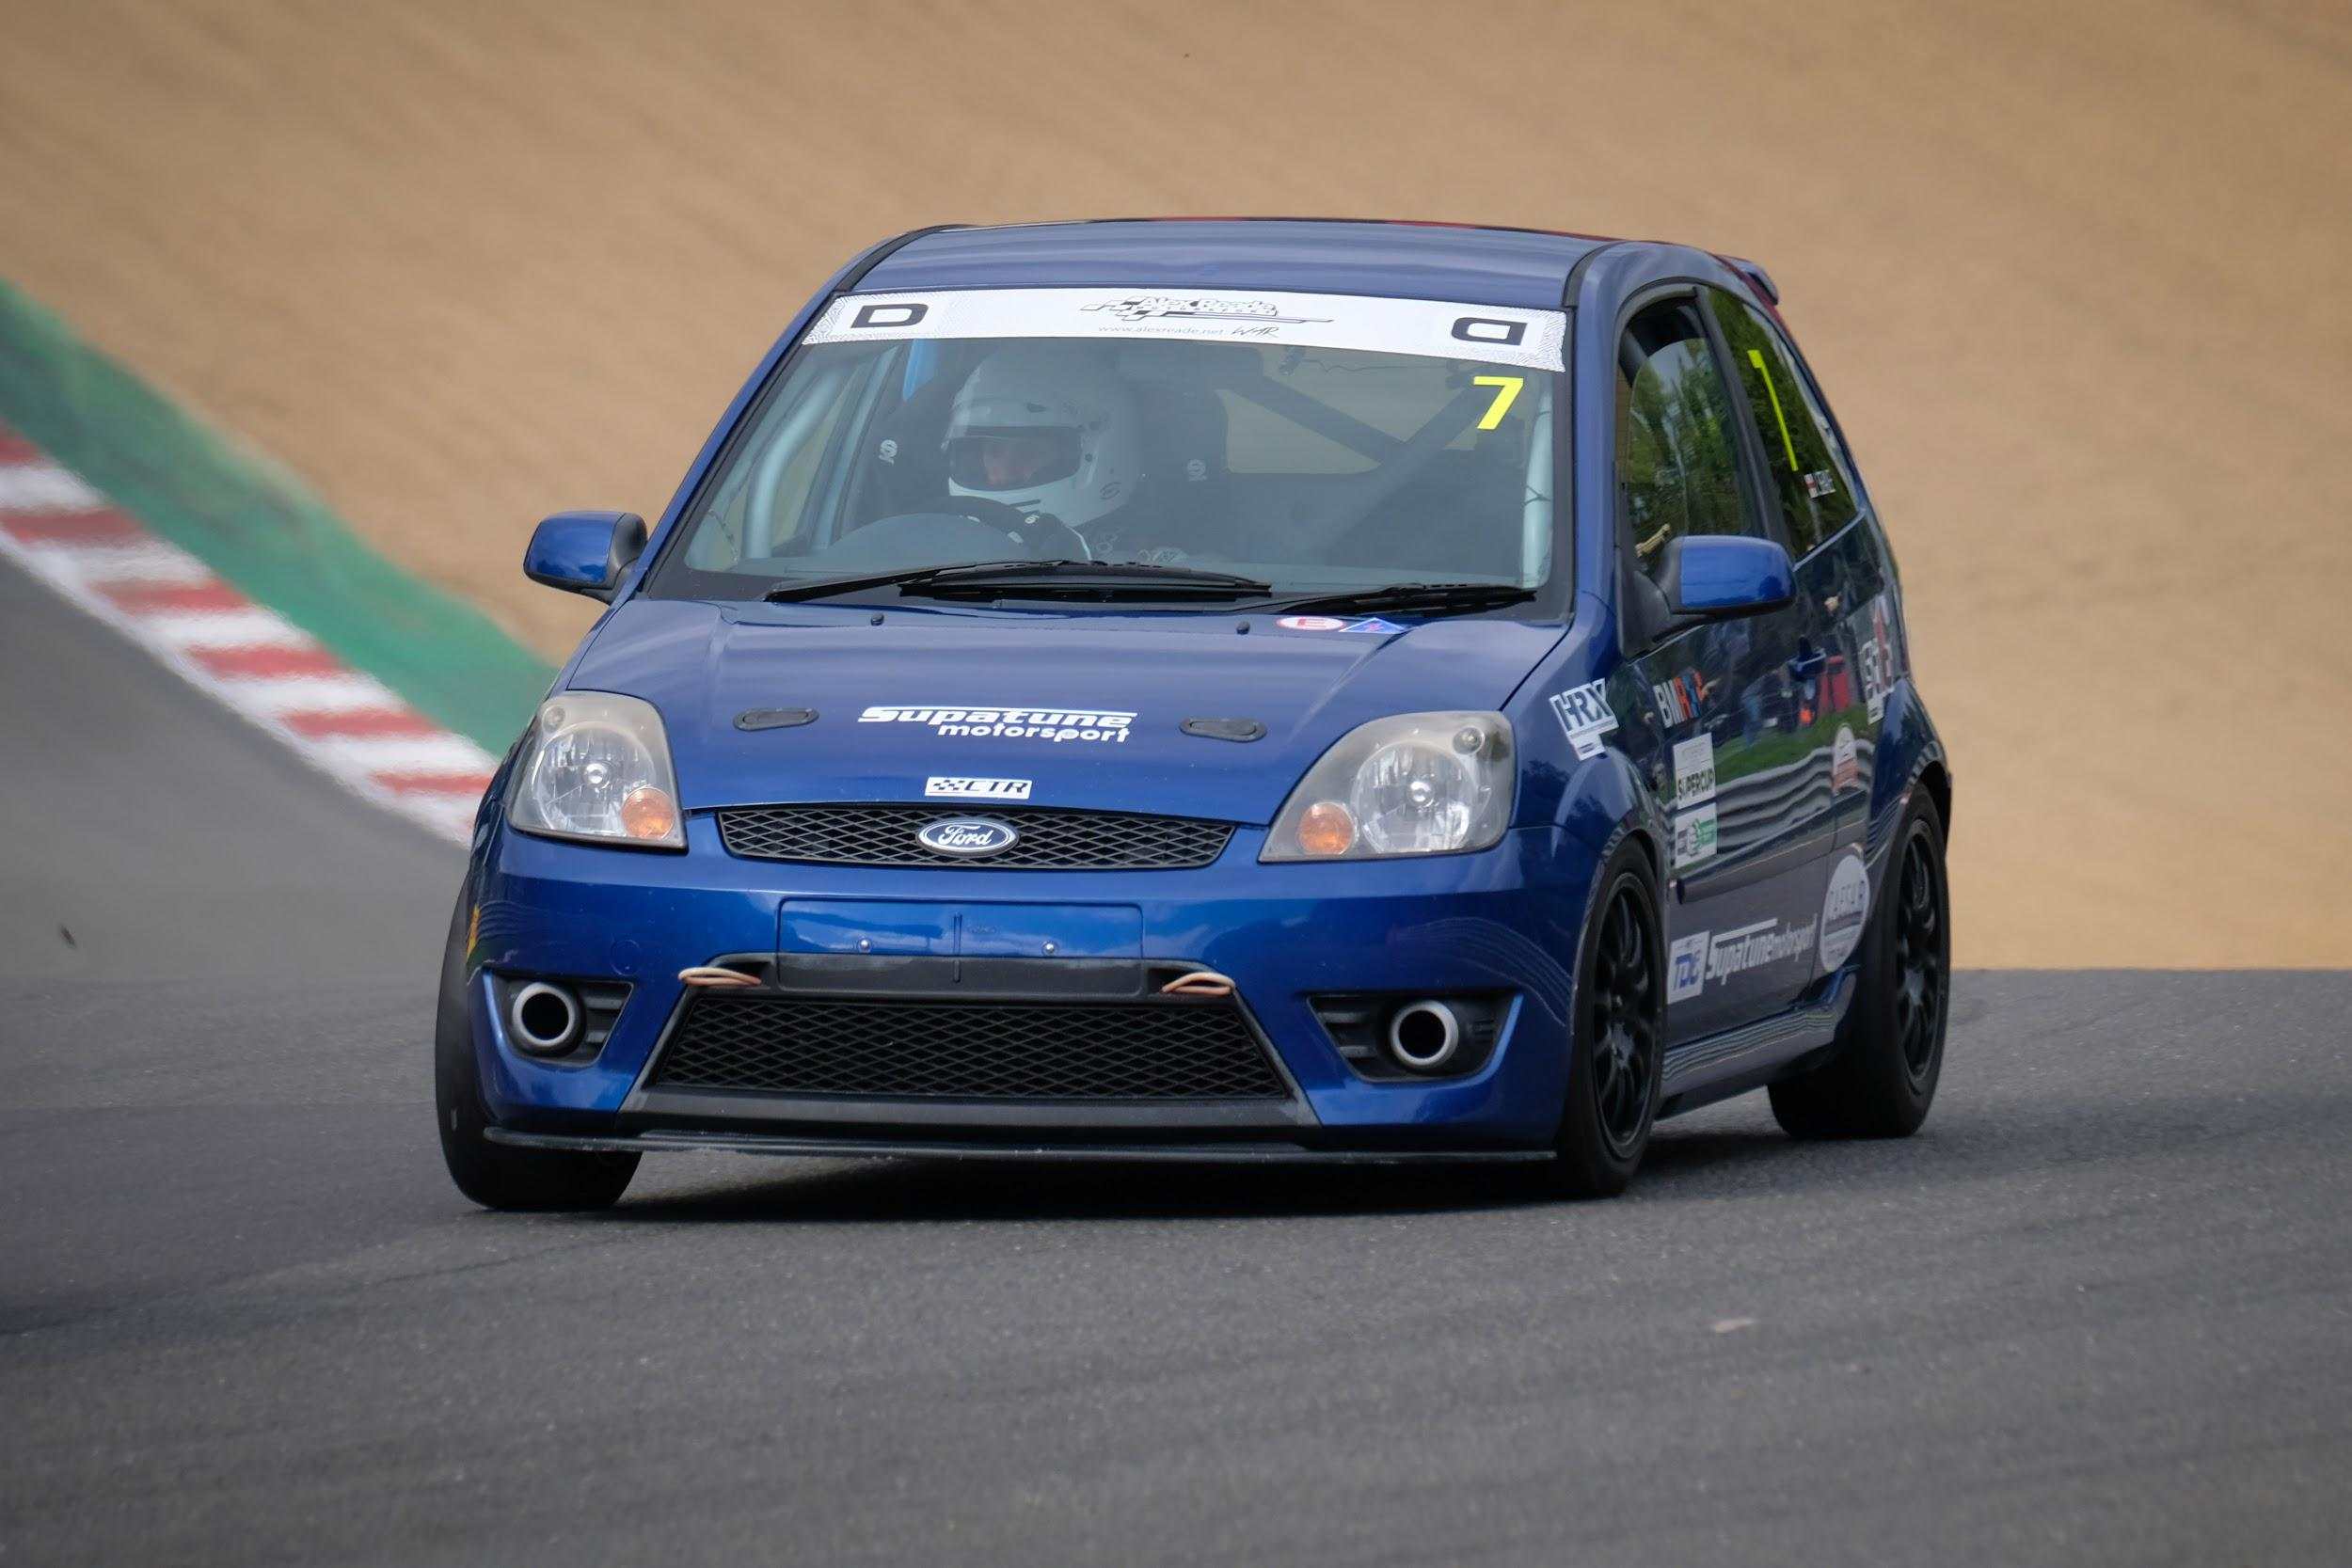
NAME: Ian Seale
RACE NUMBER: 7

Manufacturer and model: Ford Fiesta 150 ST
Colour: Blue
Number of cylinders: 4
Cubic capacity: 1999
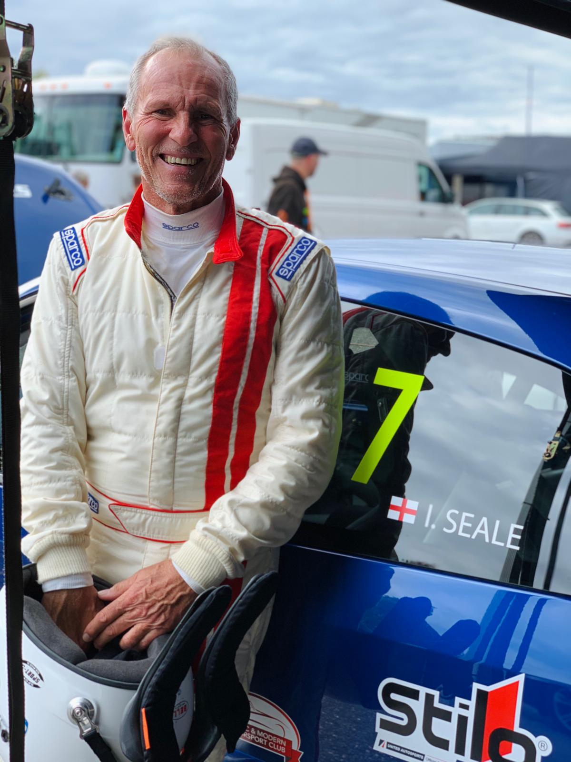
Engine power in bhp: 147
Does your engine have forced induction? No
Date of manufacture: 2005
Is the car a replica or space frame silhouette? No
Your Team: SupaTune - Colin Tester Racing
Sponsors you would like to mention: Colin Tester
Have you raced with us before: Yes since 2019
If yes, have you raced with the Super Saloons, Tin Tops or the Intermarques? Tin tops. I don’t know why but they will always be productions saloons to me

What is your day job? Hmmm – I’m an Actor, small stuff mostly, Corporate productions and Commercials, but some Film and TV (I have a small part in a BBC ‘Tudor’ production this week) – I’m also a Voiceover, and a Model too
Other hobbies or interests? Crikey! I run just short of 10km (nearly) every day, and I work out – I like to keep fit and healthy (I also have to for my job) – I really like to be outside, and when I get the chance I’m out walking in the Kent countryside – I’ve got an SLK350, so I do like to get that out on a dry day, top down and have a thrash around the lanes. Like most of the guys, I’m a big Motorsport enthusiast and MSV Season Ticket Holder, so I pretty much live at Brands Hatch
What are the circuits or events which really get you excited? I was thrilled to drive 6 Supercars at Goodwood – the history of the place – but Brands Hatch Grand Prix Circuit has everything.
What other race cars have you had? Well, I’m racing with Colin Tester in 2021, as I did in 2020. I raced with Rikki Taylor in 2019, sharing his car with Gideon September. Years ago, back in the Stone Age, I had a Davrian, which I was going to use for Sprints but Marriage and a Mortgage got in the way, before that I had an Imp.
What other series have you raced in? Back in the day, I competed in the ASEMC/LAMC Autocross series in my Imp, which I totally prepared myself. I prefer just driving these days.
What is your greatest moment in racing? They’ve all been easy up til now! I guess beating a Porsche 911 in a round, in my Imp and winning the Perseverance Shield presented by Pentti Airikkala when I was at Borough 18 MC. There’s room for more, watch this space.
What is your worst moment in racing? Brands Hatch 9th November 2019, when I rolled Rikki Taylor’s white Fiesta 150 ST. Cold, late in the day, and the circuit getting progressively more damp, I carried a touch too much speed into Paddock and got a tank-slapper – I would have gotten away with it too ‘if it hadn’t been for those pesky kids’ who put extra gravel down the previous week for the Truck Meeting – deep wet, heavy gravel, the car dug in like a tick, and went over.

What is your greatest achievement in racing? Getting here. Getting my National Race Licence. Coming back into the sport after so long, having also been a life-long supporter of the sport, and doing more than spectating while I still can.

Ian James Seale will be racing with Colin Tester Racing - Supatune, again this year in the TP class of the Production Saloons (Tin Tops) in one of Colin's Fiesta 150 STs. He'll be racing under number 7 again too. In his day-job, Ian is a bit of a superstar of the little screen, being an actor, presenter and voice-over artists for ads and commercial productions. http://www.ianseale.com/ We expect to book him for a cameo appearance in one of the videos which Alex Baldwin of F1 Videos will be making for us this year.

