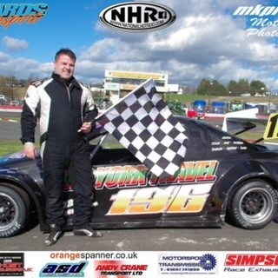
NAME: Dave York
RACE NUMBER: 196

Manufacturer and model: Vauxhall Tigra
Colour: Grey
Number of cylinders: 4
Cubic capacity: 2000
Engine power in bhp: 240
Does your engine have forced induction? No
Date of manufacture: 2019
Is the car a replica or space frame silhouette? Vauxhall Tigra Space Frame
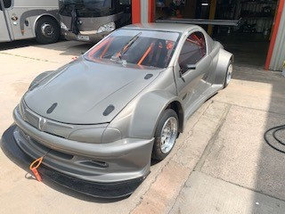
Your Team: Robba Dan Kat Jaxon & Cole
Sponsors you would like to mention: Blackman Motorsport , Chase Car Spares, P&D York Travel
Have you raced with us before: Yes
If yes, have you raced with the Super Saloons, Tin Tops or the Intermarques? Intermarques

ABOUT YOU

What is your day job? Dogs body at P&D YORK TRAVEL
Other hobbies or interests? Over Racing
What are the circuits or events which really get you excited? Brands Hatch
What other race cars have you had? National hot rods
What other series have you raced in? Oval racing
What is your greatest moment in racing? Qualifying for national hot rod world final at first attempt
What is your worst moment in racing? Blowing a engine in Friday practise at national weekend
What is your greatest achievement in racing? Winning a race at speedweekend

Dave York, multiple oval winner, has signed up to race with the CMMCS again in 2021. He has listed his Vauxhall Tigra space frame silhouette as “grey”, so clearly, looking at the picture, the car is ready to race. Going for the moody look. He thanks his team Robba Dan Kat Jaxon & Cole and his sponsors Blackman Motorsport , Chase Car Spares, P&D York Travel. Don’t miss his Facebook page at https://www.facebook.com/DaveYorkRacing/

