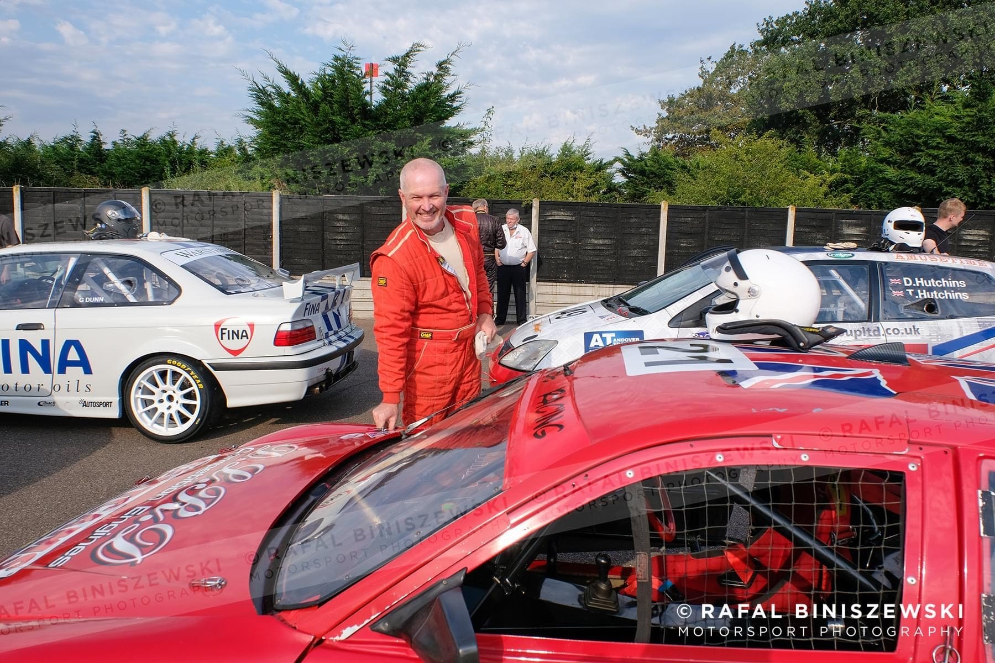
NAME: Phil Young
RACE NUMBER: 21

Manufacturer and model: Mitsubishi Colt Silhouette
Colour: Red
Number of cylinders: 4
Cubic capacity: 2000cc
Engine power in bhp: 230
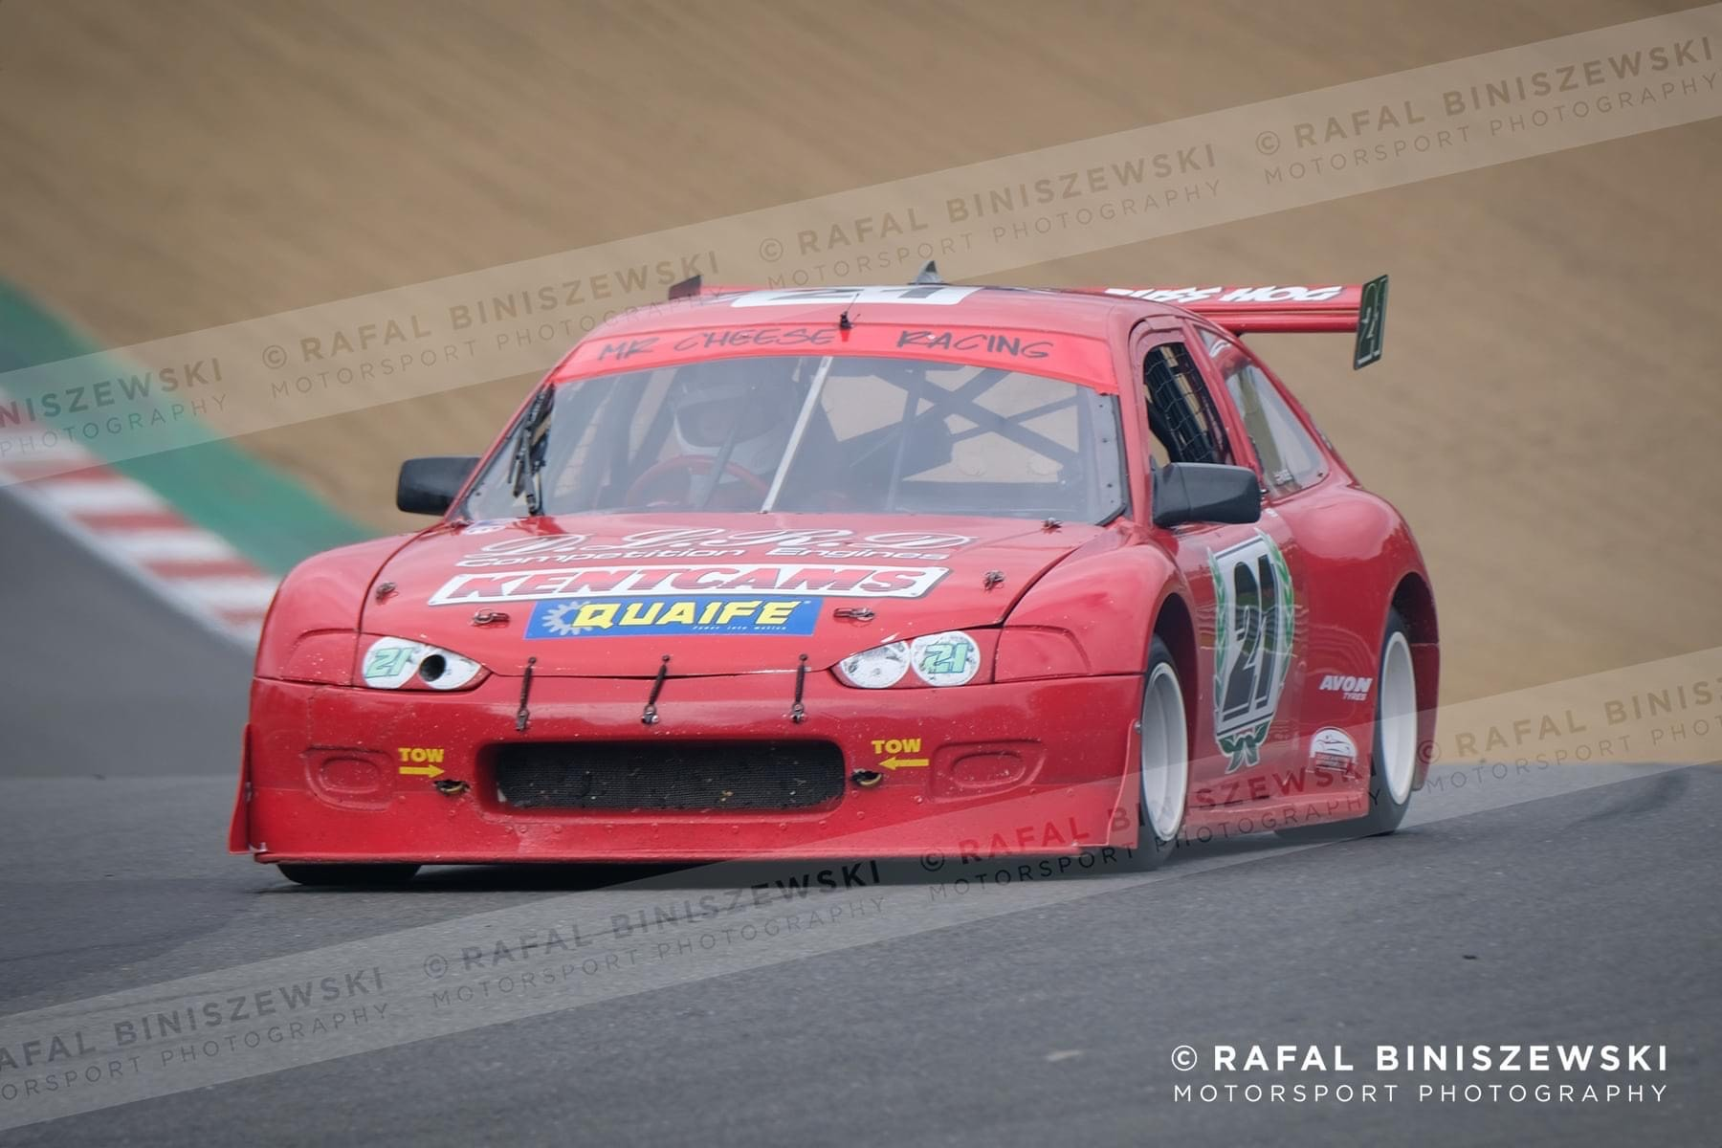
Does your engine have forced induction? Naturally aspirated
Date of manufacture: 2001
Is the car a replica or space frame silhouette? Mitsubishi Colt Space Frame silhouette
Your Team: Mr Cheese Racing
Sponsors you would like to mention: DLRD,
Have you raced with us before: Yes with you for 10 years
If yes, have you raced with the Super Saloons, Tin Tops or the Intermarques? Intermarque

ABOUT YOU

What is your day job? HGV mechanic
Other hobbies or interests? None
What are the circuits or events which really get you excited? Brands Hatch, Lydden Hill
What other race cars have you had? 2 mk 2 escorts
What other series have you raced in? Superstox, Peugeot 205 hot rod, Starlet hot rod. I’ve raced ovals for 20 years all over the country in Outlaw hot rod and had a go in National Hot Rods and Superstox. Raced extensively at Angmering, Ringwood and Essex Arena.
What is your greatest moment in racing? Winning 1600 hot rod British Championship, Western Championshite and point Championship all in one year
What is your worst moment in racing? Lifting the colt onto a trailer with no wheels left on it after going into the wall at Ipswich in a National Hot Rod
What is your greatest achievement in racing? Achieving 12 championships on ovals as a self funded and self prepared racer

