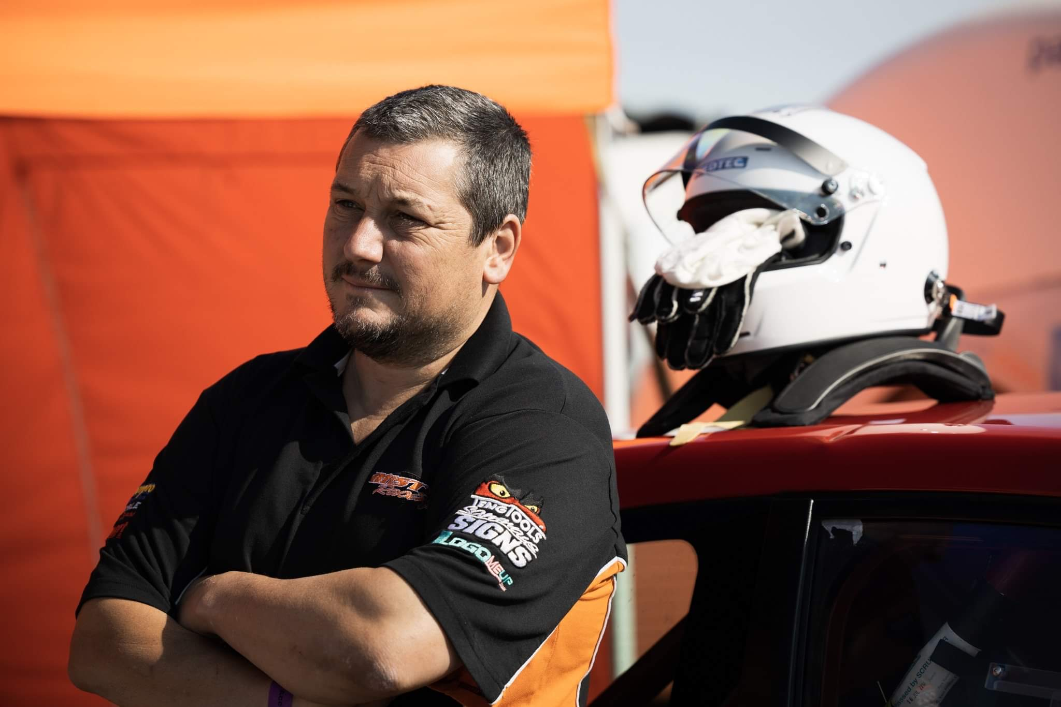
NAME: Steve Kite
RACE NUMBER: 72

Manufacturer and model: Mini Cooper S
Colour: Black & Orange
Number of cylinders: 4
Cubic capacity: 1598
Engine power in bhp: 210
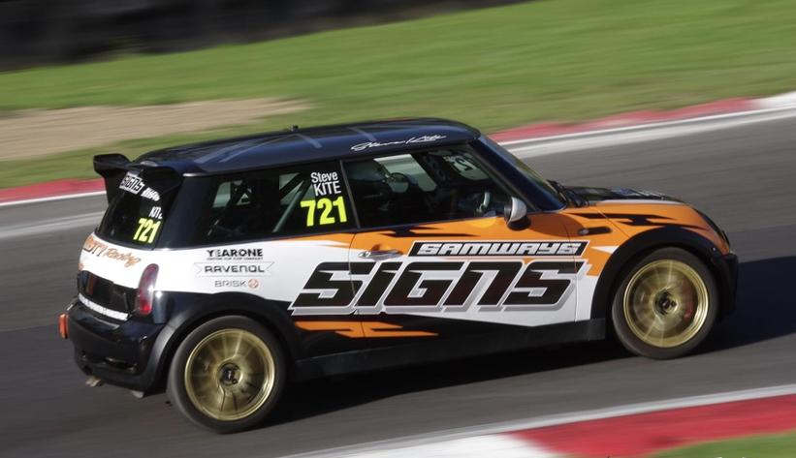
Does your engine have forced induction?: Yes supercharged
Date of manufacture: 2004
Is the car a replica or space frame silhouette? No
Your Team: Misty Racing
Sponsors you would like to mention: Samways Signs, Pole Position Prizes, It-Rocked
Have you raced with us before: No

ABOUT YOU

What is your day job? I own and run Misty Racing and I am also an ARDS driver coach
Other hobbies or interests? My wife Mandy (she told me to put that lol). No time for anything else i'm always at a race track
What are the circuits or events which really get you excited? Sad but after racing for 35 years i still get excited for every race meeting
What other race cars have you had? Too many to mention. My favourite was my Ford Anglia 105E that i raced on the short ovals
What other series have you raced in? As above! Karting, FF1600. Formula Forward, Short ovals, Hyundai Coupe's, Mazda MX5's , C1's etc etc
What is your greatest moment in racing? I won the Outlaw Hot Rod British Championship twice (2013 & 2014). It took years and many English pounds to be a British Champion. Of note over the last few years (I can't remember too far back lol) 2019 Max5 Champion 2018 Hyundai Coupe Cup Champion, 2018 4th C1 Spa 24 hours and 2017 Hyundai Coupe Cup runner up
What is your worst moment in racing? Being told at 21 that the funds/sponsors have dried up and realising I'd have to get a proper job!! Also finding out that the bars where shut at the tracks during covid
What is your greatest achievement in racing?

